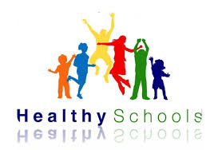 **2024-2025**

Dear Parent/Guardian:

During the next several months, a health screening will be conducted at your child’s school for grades K, 1st, 3rd, and 6th. A health screening is designed to detect certain types of health difficulties your child may be developing. The screening may consist of vision, hearing, height/weight (BMI- Body Mass Index), dental, skin, and scoliosis. Each age will have a specific required screening program.

“Screening” as defined by Florida Statues means presumptive identification of unknown or unrecognized diseases or defects by application of test that can be given with ease and rapidity to apparently healthy persons. The screening is not designed to replace examinations by your child’s physician or eye doctor for routine care or evaluation of illness or injuries.

*If you do NOT want your child to be screened, you MUST reply in WRITING to your child’s school health staff. \*\**A dental screening (grades 2 and 7) will only be done with a signed permission slip.**

You will be notified ONLY if a potential problem is detected. If you receive notification of a problem, we are requesting a follow up visit with your child’s physician AND return of the section on the referral form with the outcome of that visit for the problem(s) to the clinic staff. If you have any questions or concerns about your child’s health, please contact your child’s school nurse.

Committed to the belief that healthy students learn better,

Your School Health Staff