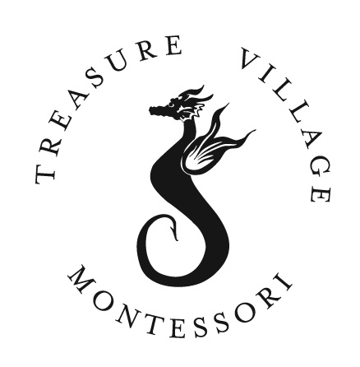
Treasure Village Montessori
86731 Overseas Highway Islamorada, FL 33036
(305) 852-3482 Fax: (305) 852-2432
Treasurevillagemontessori.com

Incoming Third Grade Student Summer Book Choices

2017-2018 School Year

Students are required to read one fiction or nonfiction book of their choice during the summer months and complete a corresponding project.

*Projects are due upon arrival at school on the first day and students need to be prepared to present these to their classmates. Students that did not complete the assignment will be expected to remain afterschool during Office Hours to read a different book and complete a corresponding report.

Treasurevillagemontessori.com
Treasure Village Montessori nurtures a love and curiosity for learning while developing students’ abilities to be successful, contributing members of society

