SCHOOL ADVISORY COMMITTEE
SSE
AGENDAS. MINUTES. SIGN-IN SHEETS. DOCUMENTS.

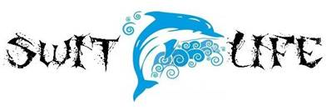

2016

