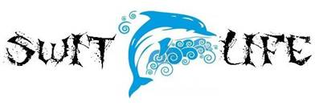

SAC Meeting Agenda January 20, 2016
Media Center 5:30pm

1. A+ School Recognition Funds- Mrs. Rodriguez shared that we are an A school and reviewed the decision of the staff on how to allocate the recognition funds. SAC members unanimously approved the decision of the staff to allocate recognition funds to all staff members that were here during the last school year regardless of whether they remain at our school this year.

2. Testing Schedule & Recent STAR Progress Monitoring- Mrs. Rodriguez shared the FSA testing schedule for 3rd-5th grade. She also reviewed STAR testing window and stated that a letter will be sent home to parents with their child’s results for STAR reading and math.

3. Ned Show- February 1st – Mary Lou Darczuk reviewed what the NED Show is and shared information about the sale of the yo-yos after the show.

4. Report Cards go home on January 27th

5. Jog-a-Thon- Mrs. Rodriguez talked about Jog-a-Thon dates and the importance of this fundraiser for PE and classroom teachers.

6. Calendar Review – Mrs. Rodriguez reviewed the January and February Calendar.

