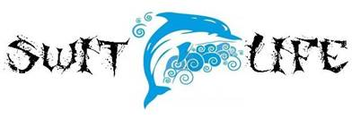

SAC Meeting Agenda January 20, 2016
Media Center 5:30pm

1. A+ School Recognition Funds

2. Testing Schedule & Recent STAR Progress Monitoring

3. Ned Show- February 1st

4. Report Cards go home on January 27th

5. Jog-a-Thon

6. Calendar Review

