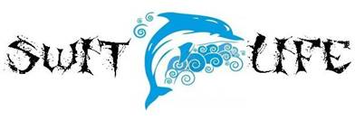

SAC Meeting Agenda May 24, 2017
Media Center 5:30pm

Mr. Unke, Principal, called the meeting to order at 5:35. He welcomed parents and teachers.

1. Construction Update
Mr. Unke stated that it looks like we WILL have to be in portables during contruction. The main entrance will be through the front office. 35th street will be used as the new bus loop.

2. 3rd grade results
Although we do not have specifics, it looks like 65% of students are considered proficient in Reading.

3. Calendar Review
June 2nd- Kindergarten promotion ceremony
June 5th- 5th grade promotion ceremony
June 6th- 1st-4th Awards Ceremony
Multiple (MANY!) field trips- please check the school calendar for specific grades and classes.

4. Shout Outs
Lion King musical- Louden and many
3rd-5th Talent Show- Geaneas and many
Mini-Mermaid Running Club- Moreira and Geaneas (and many who cameto support their 5k)
5th grade Track Meet- Kerns, Mr. and Mrs. Willis
Career/Truck Day- Schoolwide and so many community partners

5. Next Meeting
August 30th, 2017

Meeting adjourned at 6:00 pm.

