**FOCUS PARENT PORTAL**

For the protection of your child’s confidential information, FOCUS and the Monroe County School District have created the following secure procedures for establishing a Parent Portal account. To establish a parent portal account online, you must have a valid email address and the student’s birth date must be on record with the School District of Monroe County. You will also need the last 4 digits of your child’s Social Security number as well as their school-issued Student ID number. If you do not have your student’s 10-digit ID number, please contact the school.

1. Log on To This Site: <https://monroe.focusschoolsoftware.com/focus/auth/>
2. On this screen is a message from the user’s school and three (3) options to choose from:

* Parents without an account, *Start from Step Three (3) below.*
* Parents who need to add a child, *Start from Step Five (5) below.*
* Parents who need a new password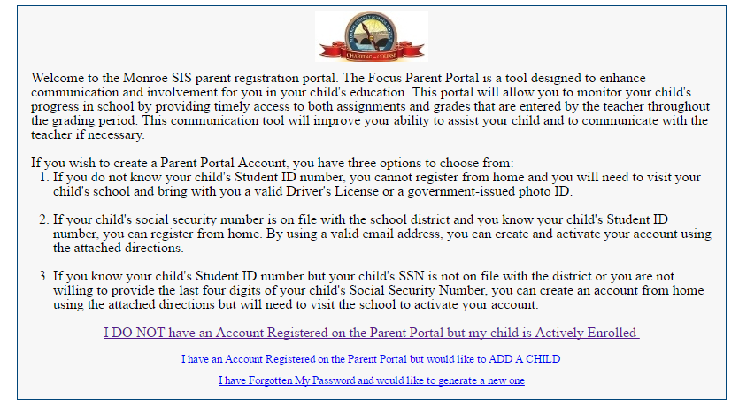

1. If you do not yet have a parent account, click **I DO NOT have an Account Registered on the Parent Portal, but my child is Actively Enrolled**.

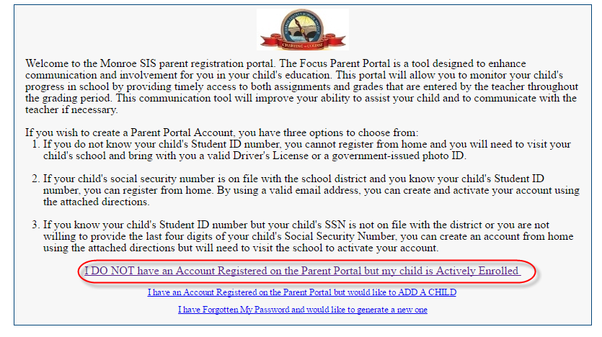

1. Enter all of the required fields with your own information. Your child’s school has set up these requirements to create a parent account. Click **Submit**.

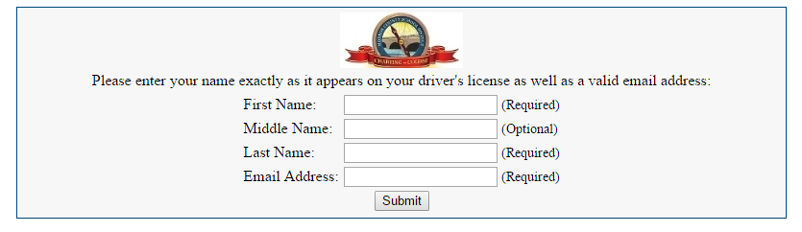

1. Enter the required information to identify your child. Your child’s school has set up these requirements to link a student to a parent account. Multiple children must be added one at a time; an option to add another child will be available in the next step. Click **Add Student**.

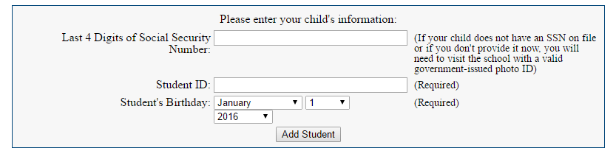

1. Your child’s name will display on the screen, and the school will receive your request to link to this student’s account. To add another child, click **Add Another Child**. Otherwise, click **Create My Account**.

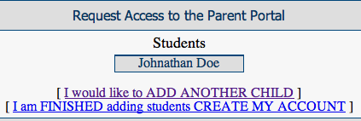

1. A. To **Add Another Child**, enter all of the information required and click **Add Student**.

***NOTE: This step can be completed as many times as necessary, or at a later date if needed.***



1. When you click **Create My Account**, a confirmation message will appear with your username and password. A link to the Parent Portal login screen is also provided.

***NOTE: Your username and password will not be emailed. Make sure to write it down or put it in your phone.***

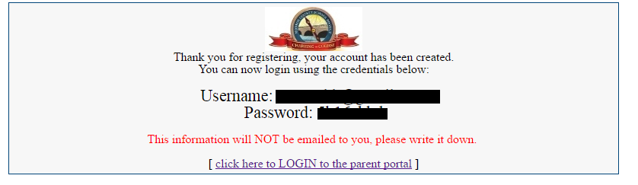

1. If you did not click on the link on the previous screen, you can access the Portal Login page at <https://monroe.focusschoolsoftware.com>. Enter your new username and password on the Portal login screen.. Click the **Login**.

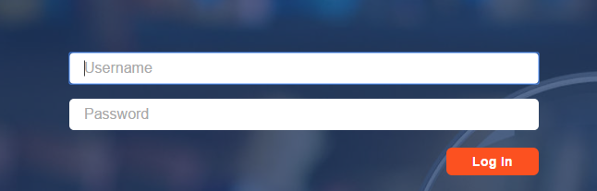

1. When you first log into Focus, you will be prompted to change the generated password. Enter the generated password, a new password, and the new password again to verify the entry. Click the **Save** in the top right corner.

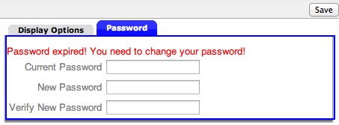

1. If you do not have a password, you can generate a new one from the **Request Access** screen.

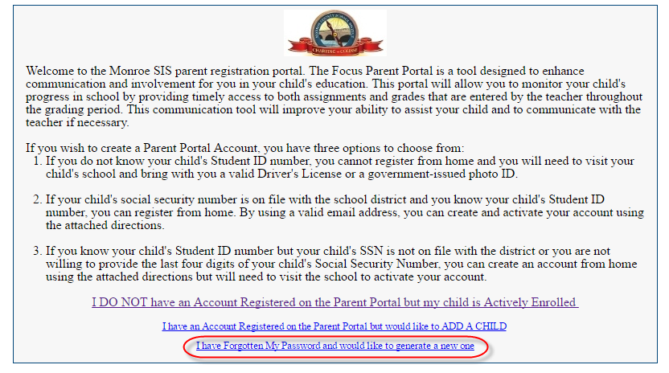

1. If additional actions need to be taken before you can view student information, an alert will display on the main Portal page. Depending upon your school’s setup requirements, you may need to visit your school and present a valid photo ID to view any student information.

